Anchorage School District Fine Arts Department

6th Grade Orchestra and Band Registration Slip and Contract

**Commitment:** Orchestra and Band is a **one-year** commitment. Once students are enrolled, **they are expected to remain in the program for their entire sixth grade year.**

**Behavior:** Excellent behavior is **required.** Orchestra and band classes are usually large. Class time is short; we need every minute for learning how to play the instruments!

**Effort:** Learning an instrument is a challenge! You get out of a musical instrument what you put into it. Students must **try their best** and develop a “can-do” attitude.

**Home Practice:** It is very important to set up a daily home practice schedule and stick to it. Consider instrument practice as **daily homework.**

**Supplies:** In addition to an instrument, certain supplies are required for class. Students must get all the supplies on the Supply List and **bring their supplies and instrument to class every day.**

**Equipment:** Musical instruments are fragile. Students must use all equipment properly and **handle only their own instrument.** Students and the responsible adult are liable for any damages they cause. Students work together to help set up and take down the chairs and stands in the room.

**Performance: Students are expected to participate in all concerts.** This includes daytime school assemblies and one or two evening performances.

**Safety:** Gum, candy, etc. are unsafe and are **not** allowed in class.

**Grades:** Each quarter, orchestra and band students will receive academic marks in instrumental music class. Marks are O, S, and N (Outstanding, Satisfactory, Needs Improvement).

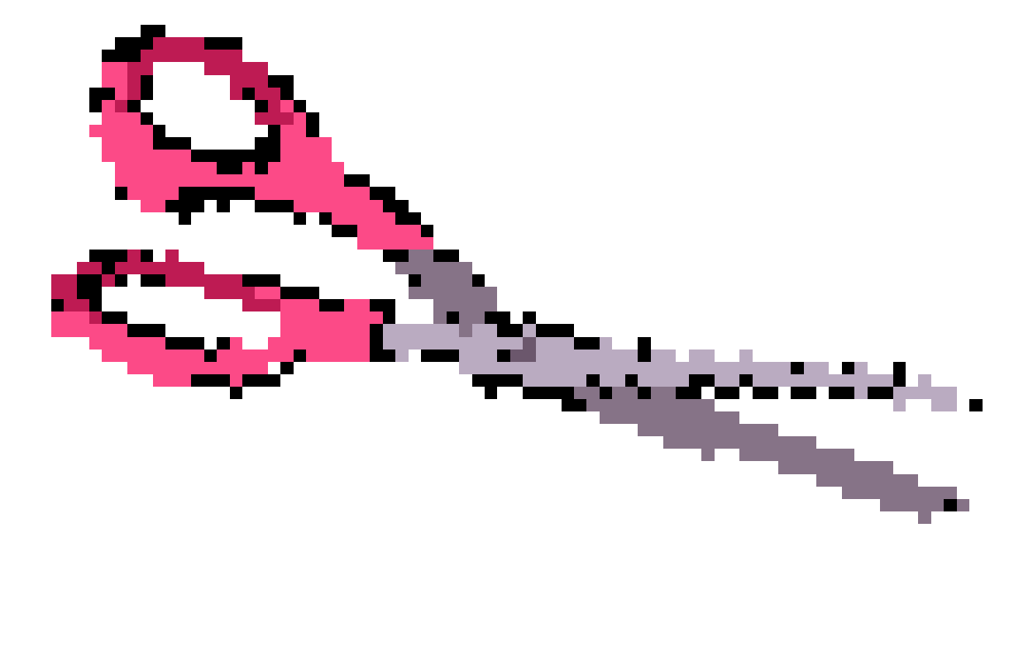 Please save top half and return bottom portion to your teacher by the **second Friday in September.**

-------------------------------------------------------------------------------------------------------------------

6th Grade Orchestra and Band Registration Slip and Contract

Name (please print) ________________________________________________ School _________________________________

Classroom Teacher _______________________ Name of Parent/Guardian(s) ________________________________________

Instrument 1st Choice ________________________________ Instrument 2nd Choice ________________________________

Primary Phone ____________________________________ Secondary Phone _______________________________________

Address ___________________________________________________________________ Zip Code ______________________

Email ______________________________________________________________________________________________________

Instrument(s) previously studied ____________________________________________ How long? ______________________

I have read and accepted the above contract and am ready to be a part of the instrumental music program at my school.

_______________________________________________________________

Student Signature

I have read and accepted the above contract and give my child permission to enroll in the instrumental music program.

_______________________________________________________________

Parent/Guardian Signature